Half Yearly Progress Report on Research Work carried out from 28.03.2013 to 27.09.2013
Name and address of the candidate : P. Mohandass
Reg. No. P8851
PG and Research Dept. of Chemistry
Saraswathi Narayanan College
Madurai-22.

Occupation if any and address : Associate Professor of Chemistry
Saraswathi Narayanan College
Madurai-22.

Name, designation and address of the : Dr. K. Radhakrishnan
Guide Associate Professor of Chemistry
Saraswathi Narayanan College
Madurai-22.

College where the candidate carried : PG and Research Dept. of Chemistry
out the research Saraswathi Narayanan College
Madurai-22.

Whether the candidate has paid annual
Research fee (mention amount, date of : No
remittance, place of bank, etc.)

Detailed one page report on the progress : Separate sheet Attached
of research work carried out by the
candidate (attach separate sheet)

Remark, if any by the guide : Nil

Signature of the candidate Signature of the research supervisor

Half Yearly Progress Report on Research Work carried out from 28.03.2013 to 27.09.2013
Characterization of 2-benzylidene-1,3-indandione and its derivatives
All chemicals used were purchased from Sigma Aldrich. The purity of the compounds was checked by TLC on silica gel G plates. All the compounds were characterized as 2-benzylidene-1,3-indandione and its derivatives (Fig.1) by UV-Visible, FT-IR and NMR spectral techniques. UV-Visible spectra were recorded on a CARY VARION (V 550), CHCl₃ was used as a solvent. Infrared spectra were obtained on a PARAGON 500 spectrometer on KBr pellets. ¹H and ¹³C spectra were obtained on a BRUKER AMX 400 MHz spectrometer. The chemical shift of ¹H was measured with the peak of CDCl₃ at δ 7.29 as the internal reference, while those of ¹³C were recorded with the central peak of CDCl₃ at δ 77.03 as the internal reference.
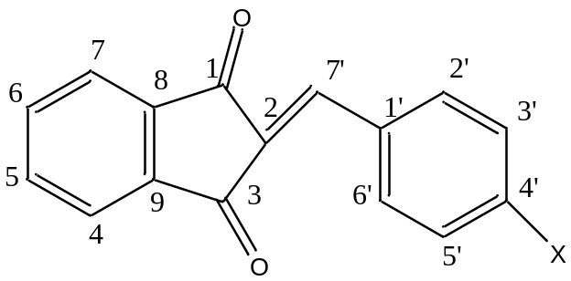
Figure 1
where X is the substituents viz. -OMe, -Me, -H, -Cl, -Br, and –COOH

Signature of the research supervisor

